**Assignment 1**

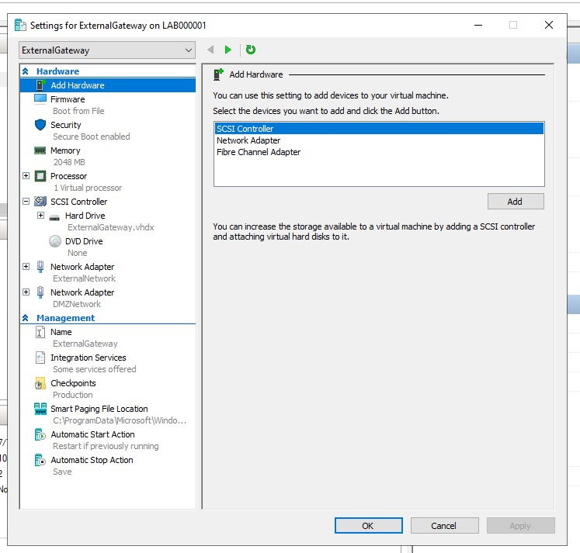**Activity 1:**Show the virtual switch configuration and display the IP address of each VM. Demonstrate that your Ubuntu Desktop has internet access.

**External Gateway – Settings**

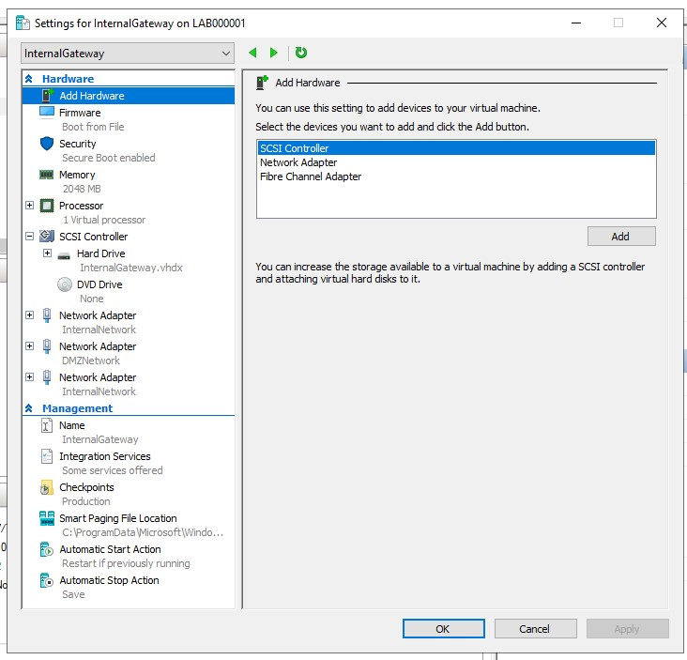

**Internal Gateway – Settings**

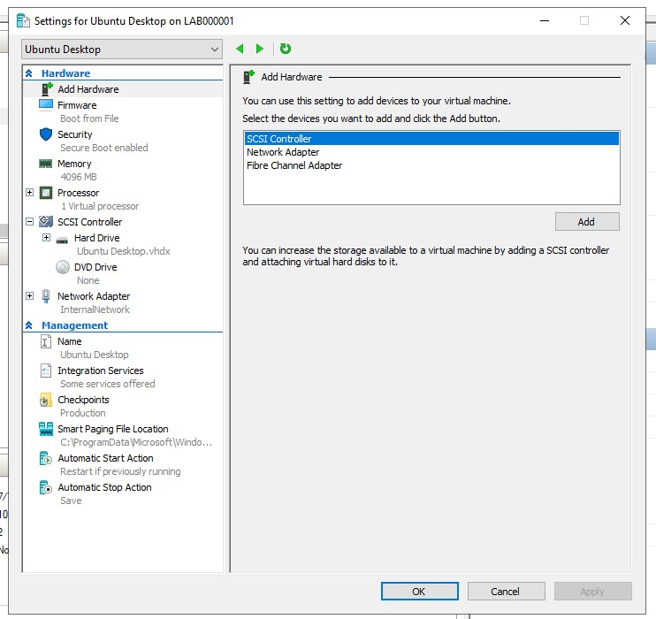

**Ubuntu Desktop – Settings**

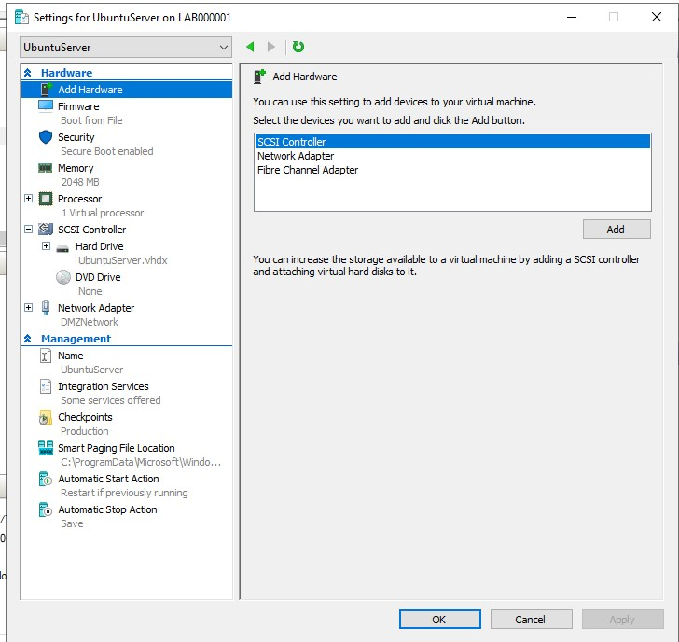**Ubuntu Server – Settings**

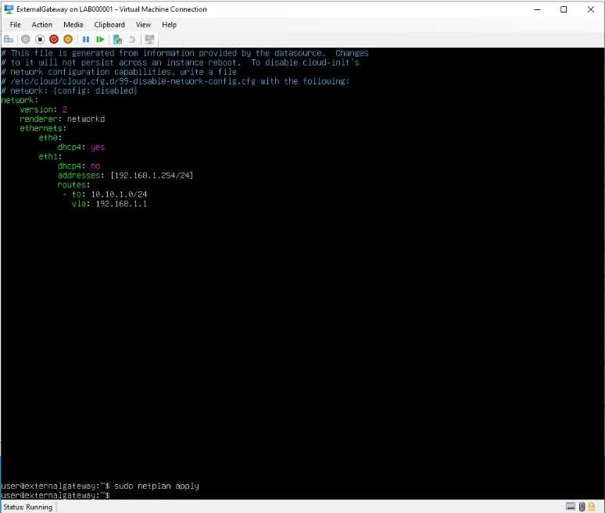

**External Gateway – Netplan**

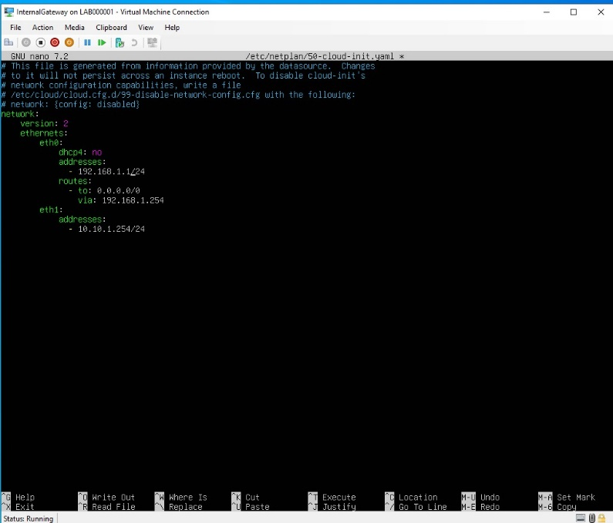

**Internal Gateway – Netplan**

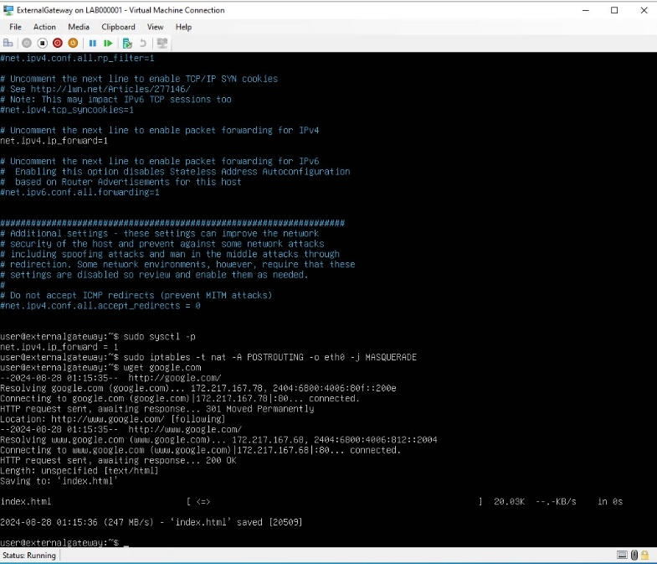

**Ubuntu Server – Netplan**

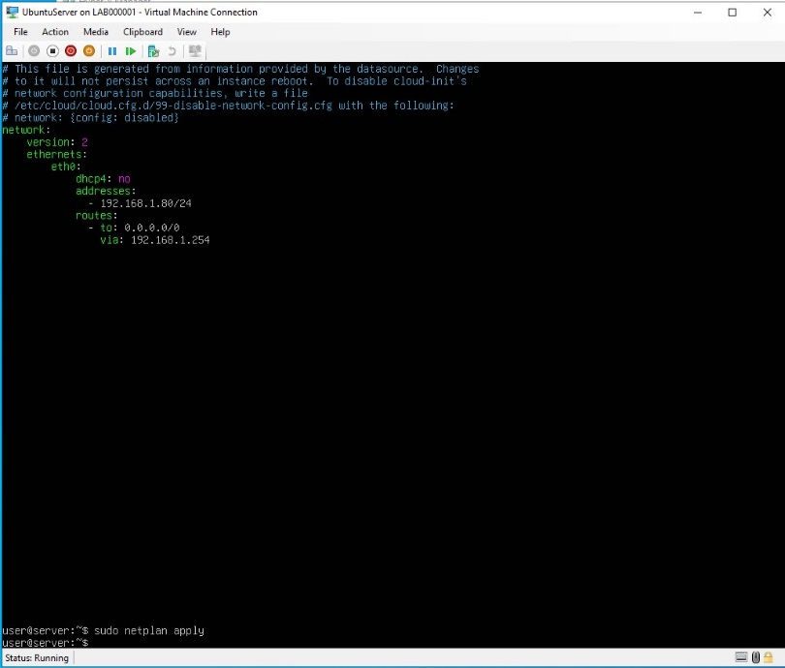

**External Gateway**

**– Ipv4 Forwarding /wget google.com**

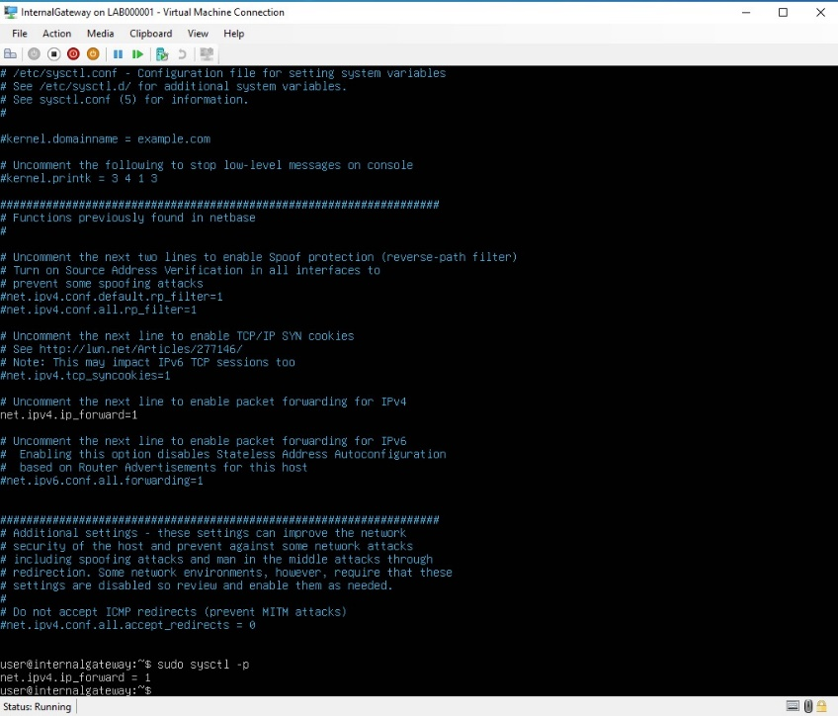

**Internal gateway**

* **Ipv4 Forwarding**

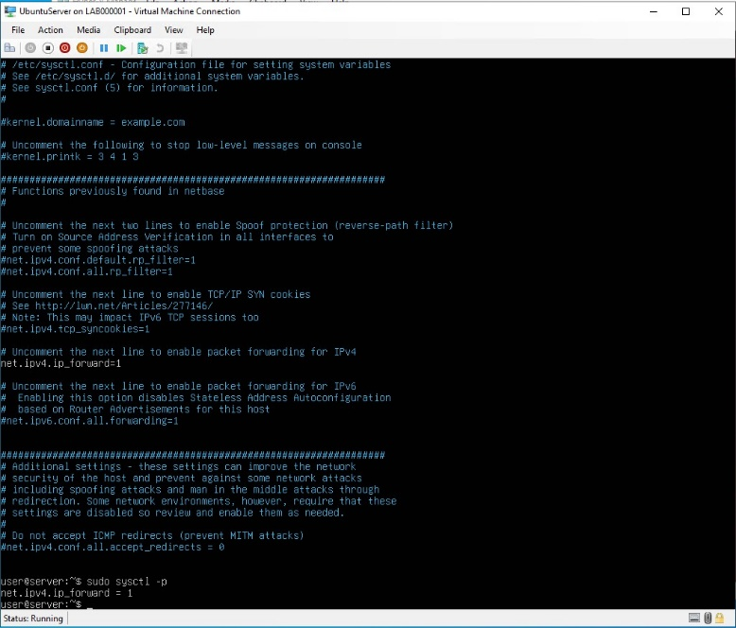

**Ubuntu Server**

* **Ipv4 Forwarding**

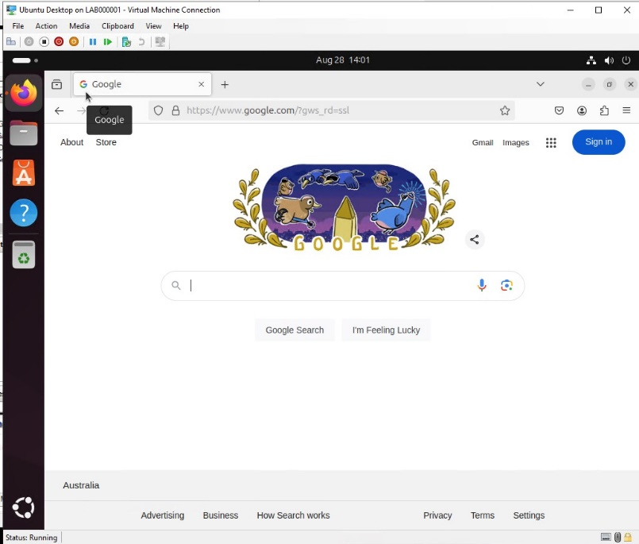

**Ubuntu Desktop – Google working / Internet**

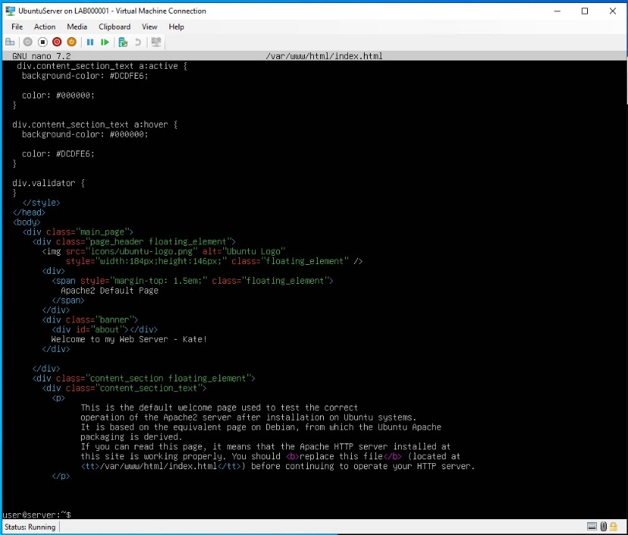**Activity 2-1:**Open the browser on your Ubuntu Desktop and demonstrate access to your webserver via both HTTP and HTTPS (http://192.168.1.80 and https://192.168.1.80). Additionally, provide an example of your proxy blocking access to a specific website.

**Ubuntu Server – Welcome to my server**

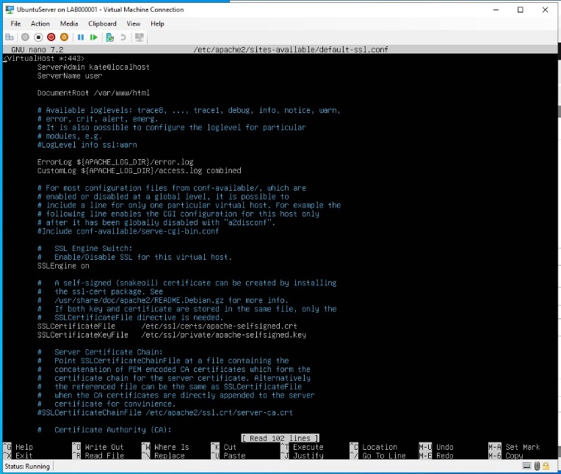

**Ubuntu Server**

* **SSL Host virtual Configuration**

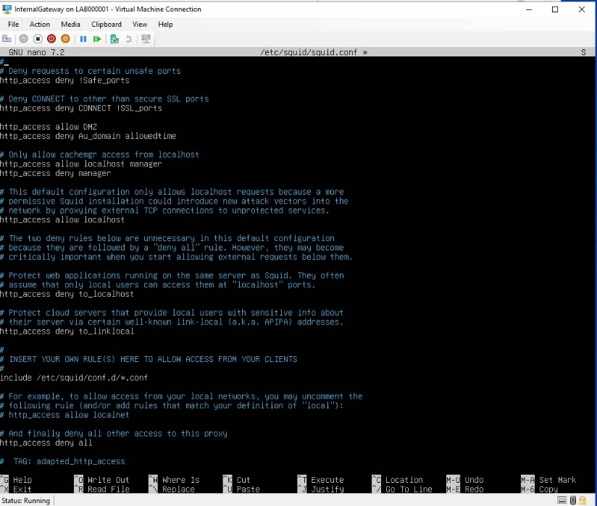

**Internal Gateway – Squid Configuration**

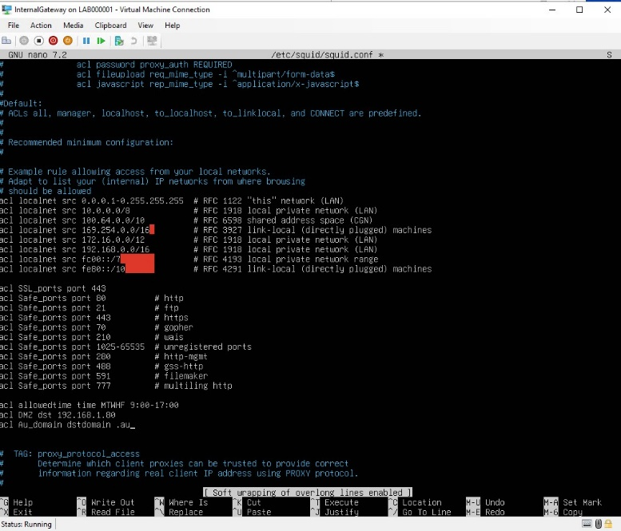 **Internal Gateway – Squid added Rules**

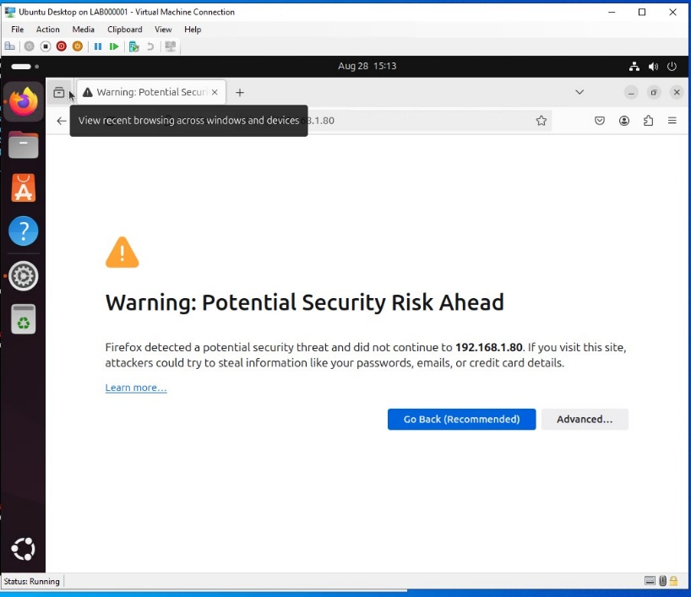

**Ubuntu Desktop – http warning for 192.168.1.80**

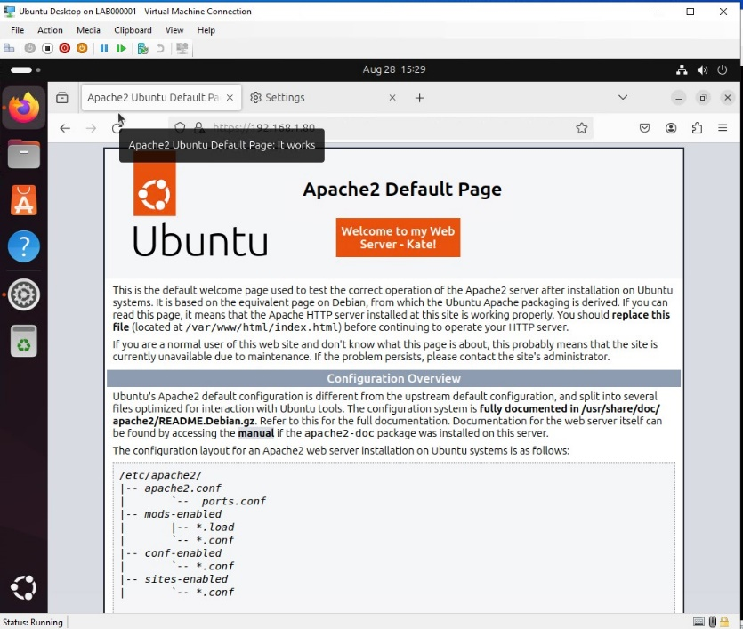 **Ubuntu Desktop – HTTP – Webserver**

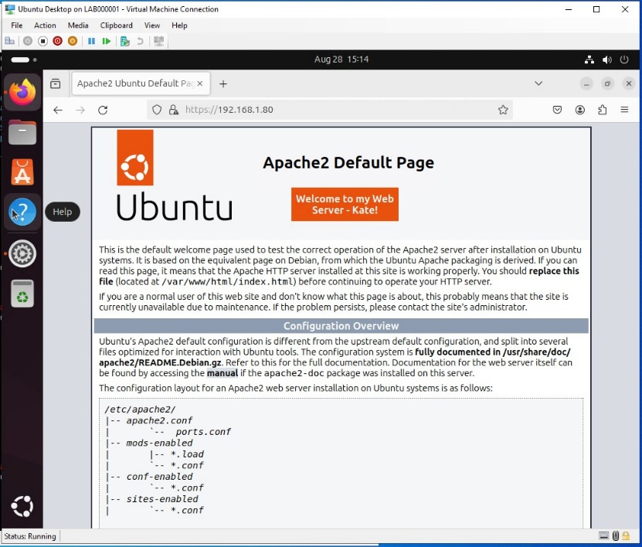

**Ubuntu Desktop – HTTPS Web Access**

**Activity 2-2:**From your Ubuntu Desktop, open your website using the domain name you created. On your Internal Gateway, run the command dig your-website-URL and demonstrate that it resolves the domain name to the webserver's IP address.

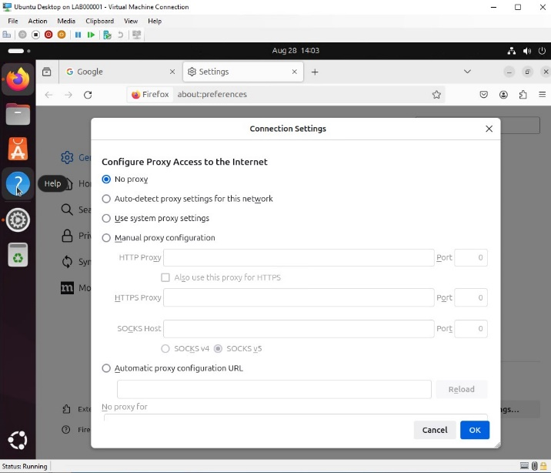**Ubuntu Desktop – No Proxy from previous Activity**

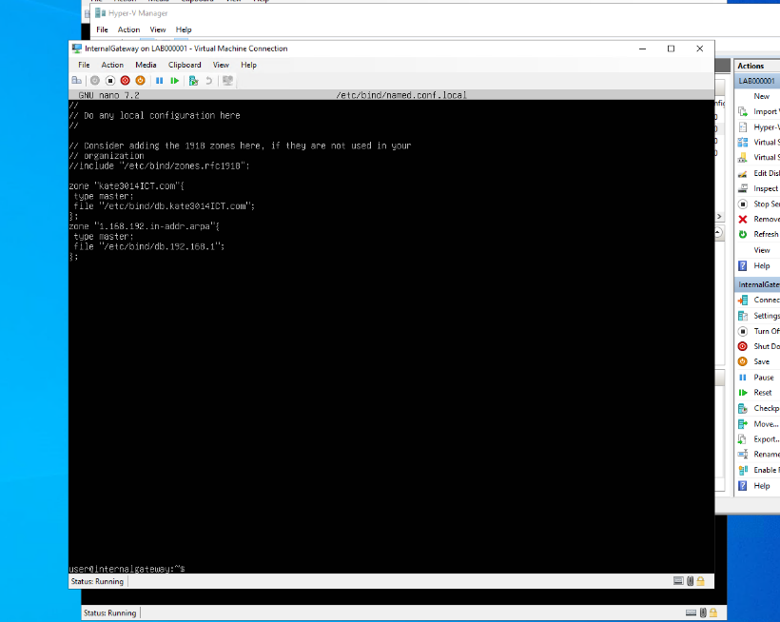

**Internal Gateway**

* **Bind9 Zone Configuration**

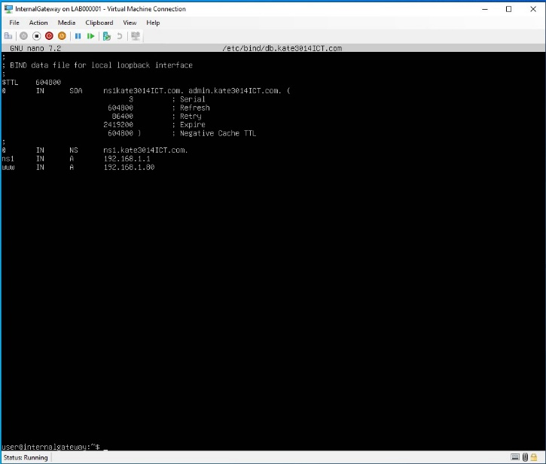

**Internal Gateway**

* **Create Forward Lookup Zone File**

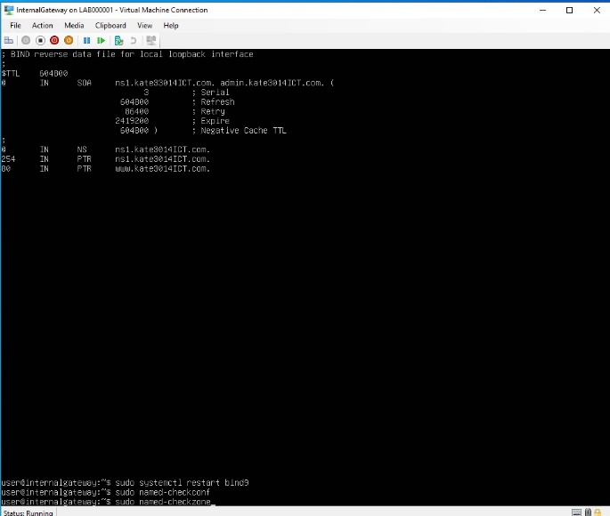

**Internal gateway**

* **Create Reverse Lookup Zone File**

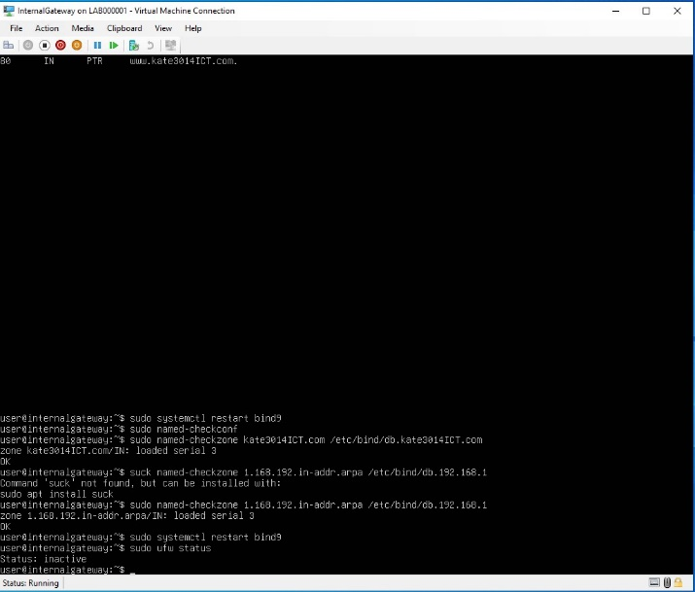

**Internal Gateway**

* **BIND9 Configuration (Correct)**
* 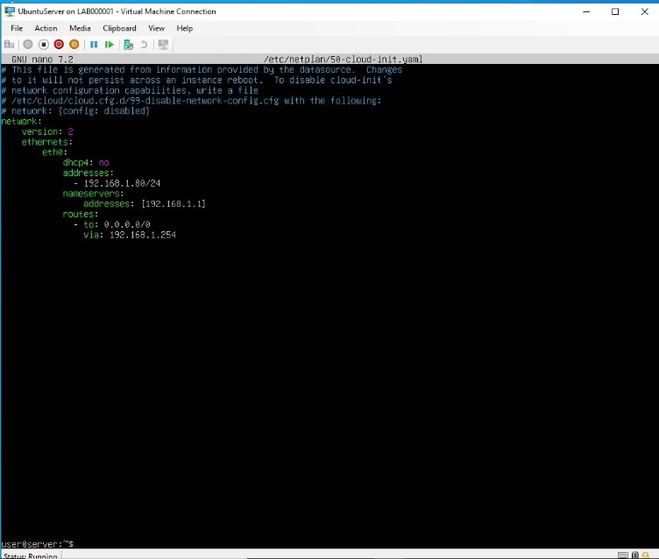**Firewalls Inactive**

**Ubuntu Server**

**– New DNS Configuration**

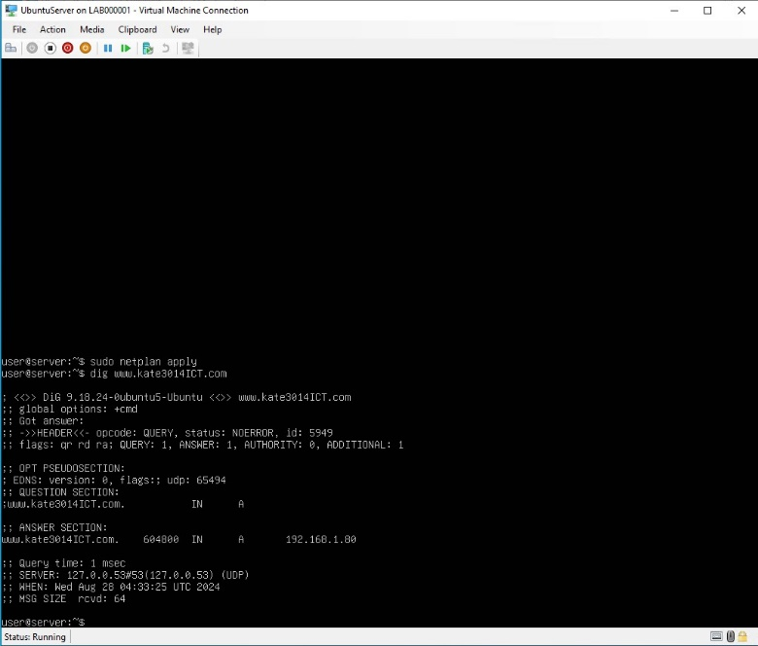**Ubuntu Server**

* **Dig – www.kate3014ICT.com**

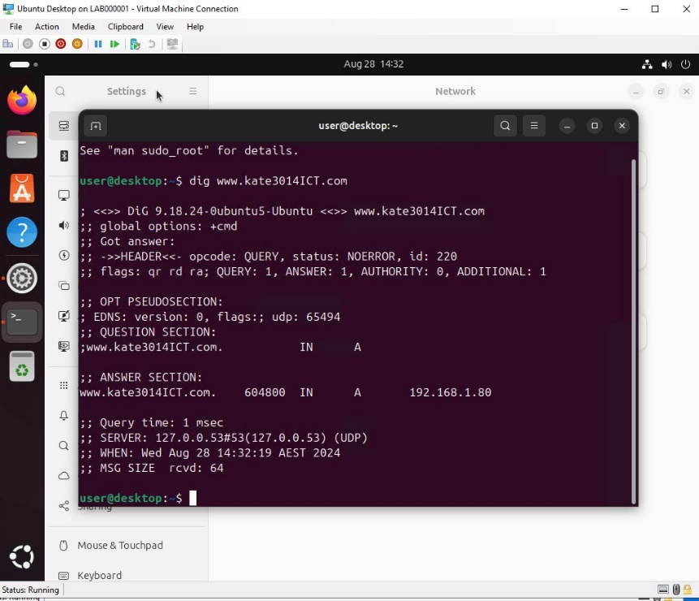

**Ubuntu Desktop**

* **Dig www.kate3014ICT.com**

**Activity 3:**Demonstrate how your email server works. You should be able to send an email from your server and from your client, showing that they are received on the server side.

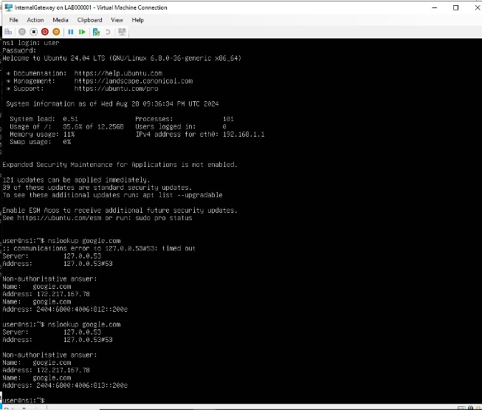**Internal Gateway**

**-nslookup google.com**

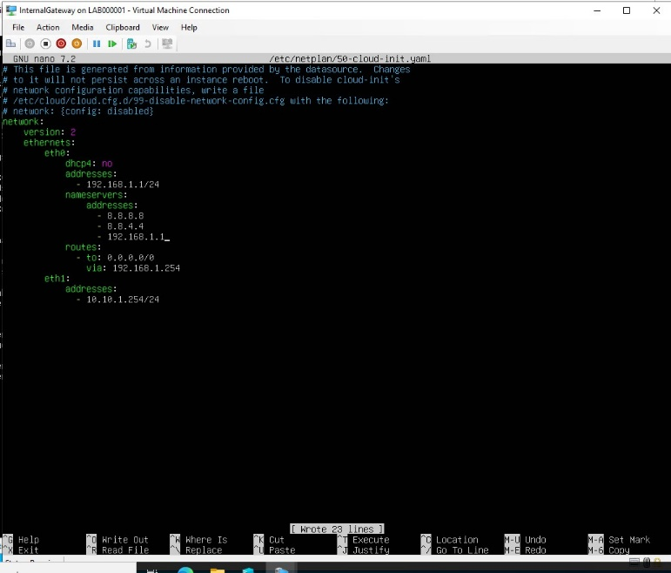**Internal Gateway**

* **Nameservers added**

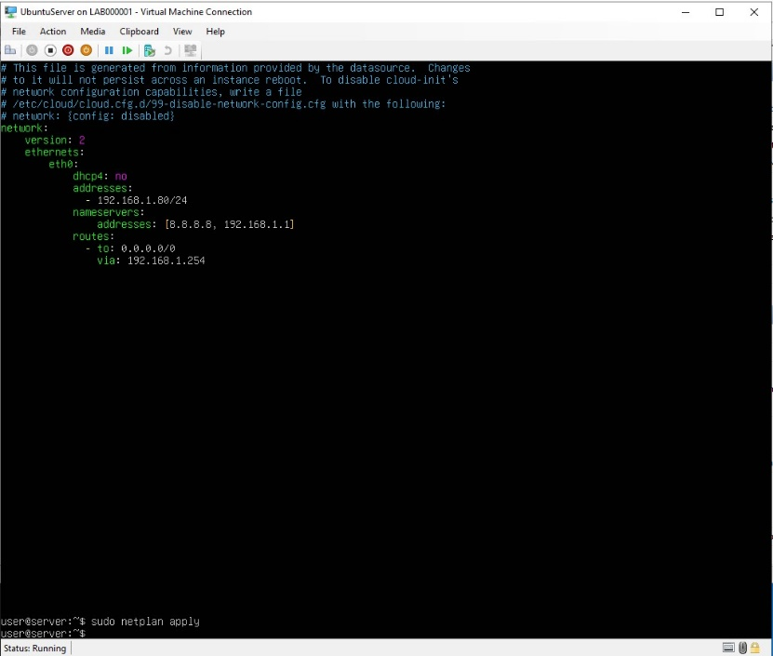

**Ubuntu Server**

* **Nameservers added**

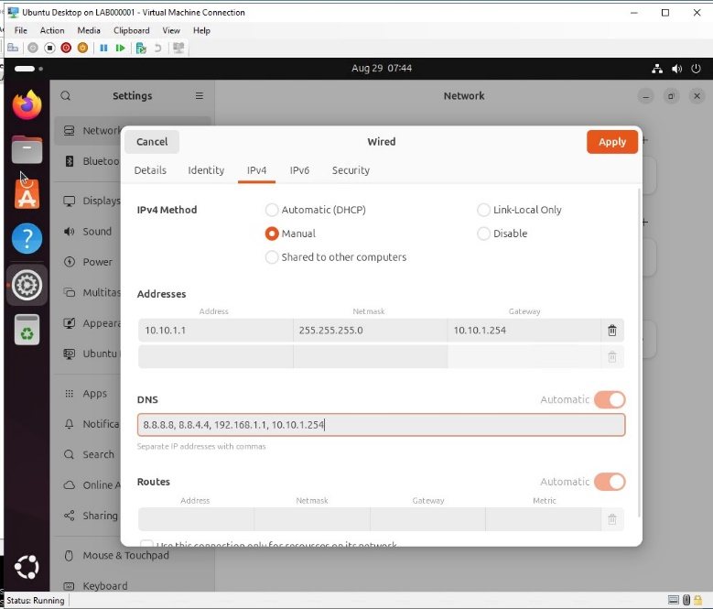**Ubuntu Desktop**

* **Manual IPv4 Configuration**

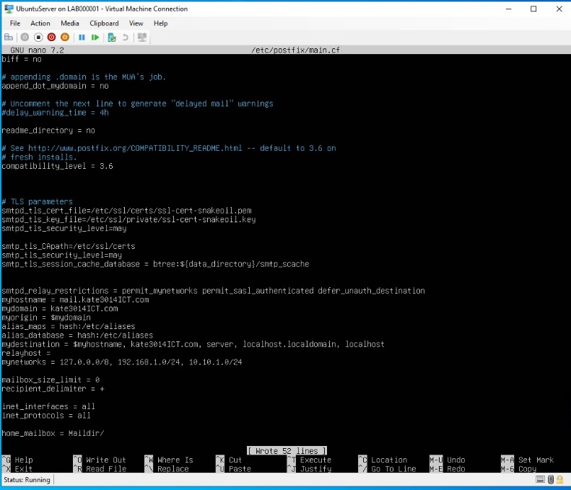

**Ubuntu Server**

* **Postfix configuration**

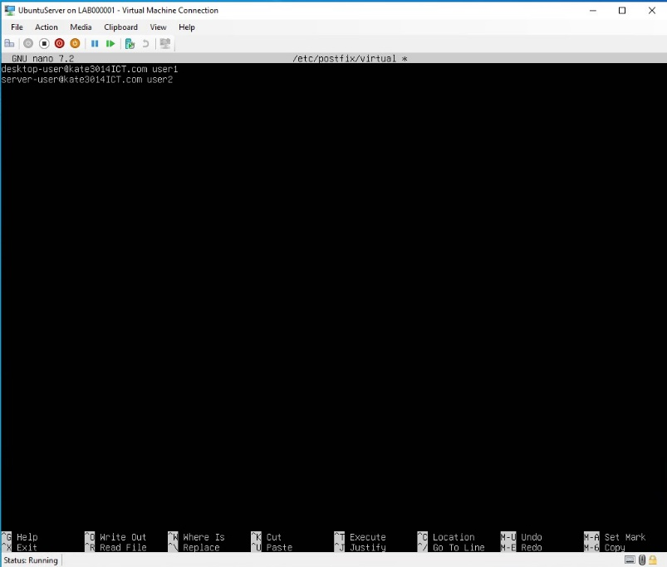

**Ubuntu Server**

* **Add Aliases**

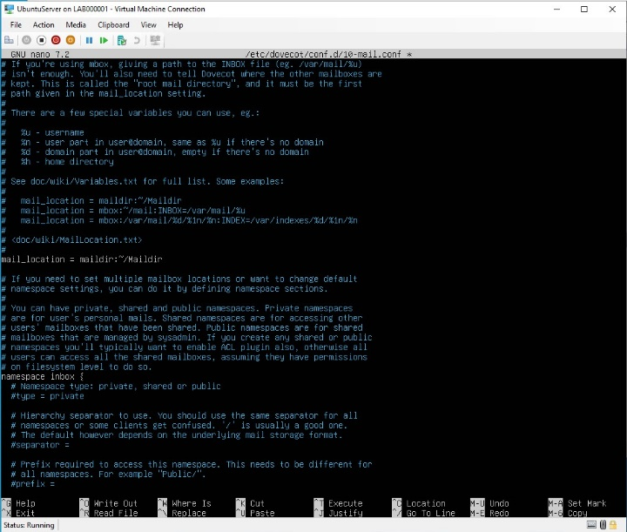

**Ubuntu Server**

* **Dovecot Configuration**

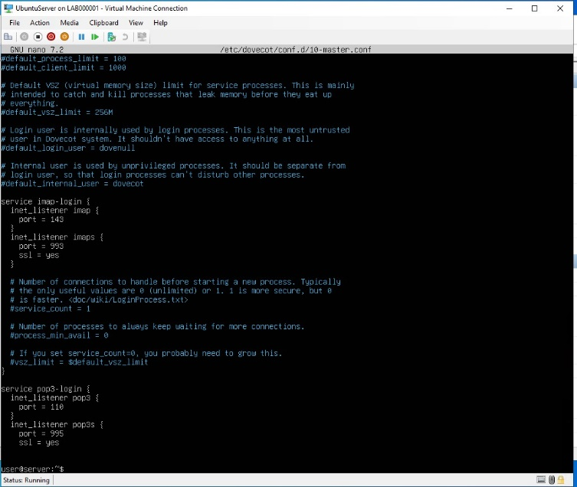

**Ubuntu Server**

* **Dovecot Port Listening**

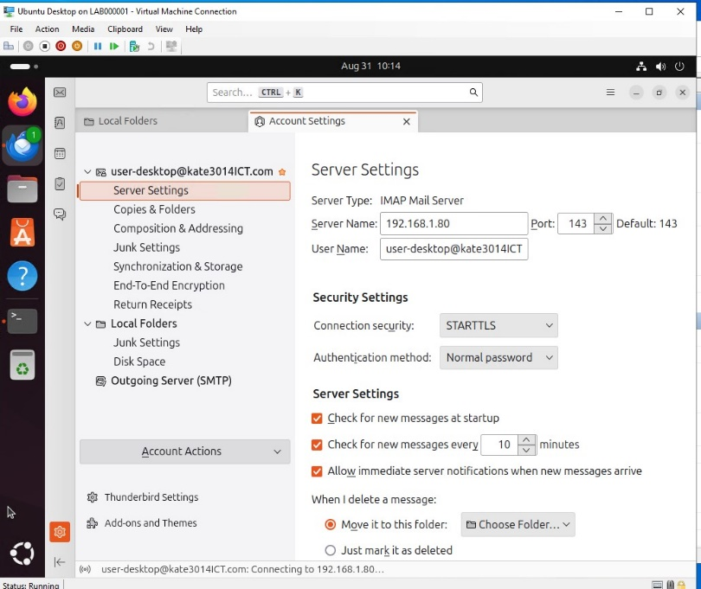

**Ubuntu Desktop**

* **IMAP & POP3 set up**
* **Email account set up**

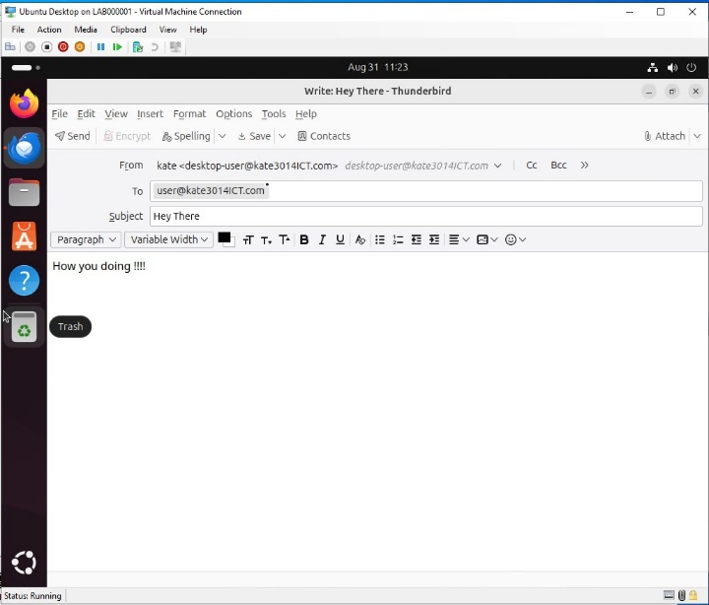

**Ubuntu Desktop**

* **Thunderbird set up**
* **Sending email to server client**

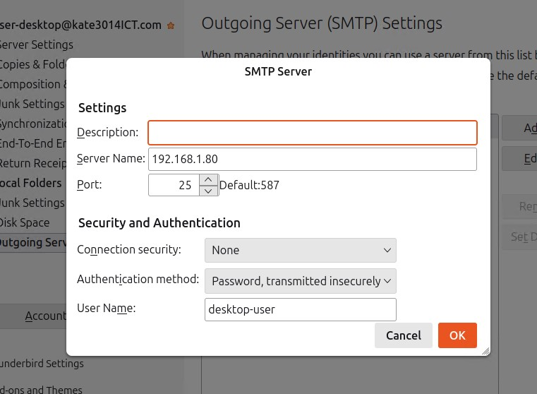

**Ubuntu Desktop**

* **SMTP server configuration**

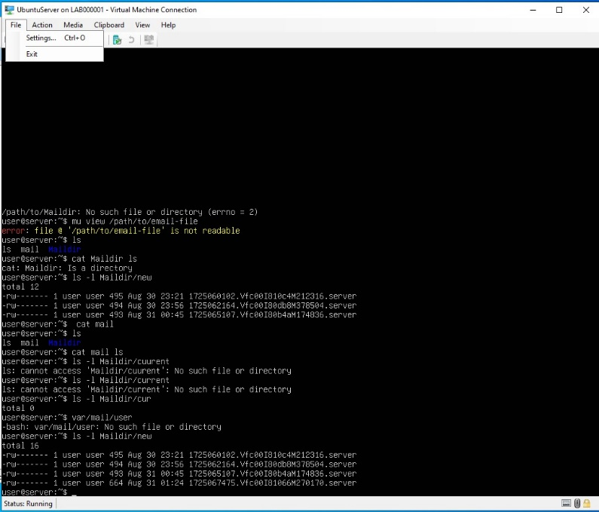**Ubuntu Server**

**-Email received**

**Activity 4-1:**Display the iptable rules configured on your External Gateway and show that you can access the web server from the Azure host (Windows).

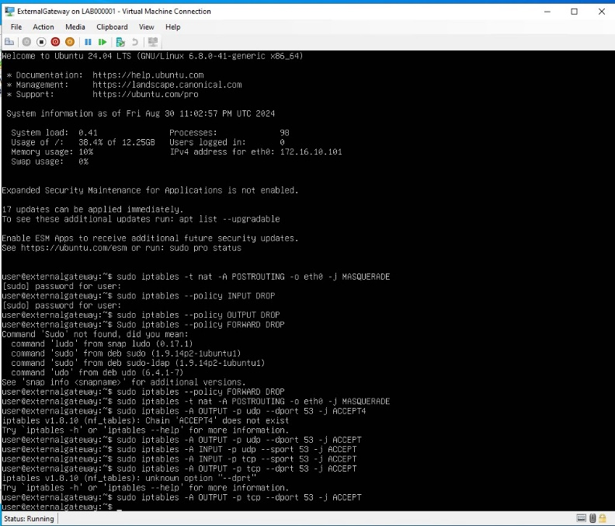**External Gateway**

* **IP tables added**

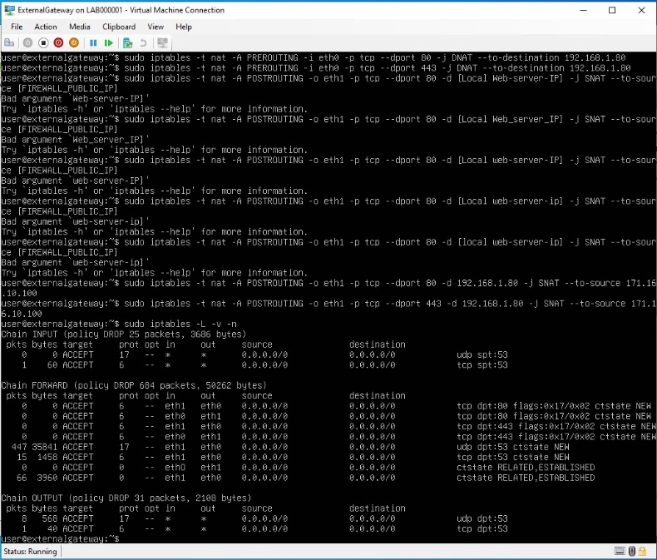

**External Gateway**

* 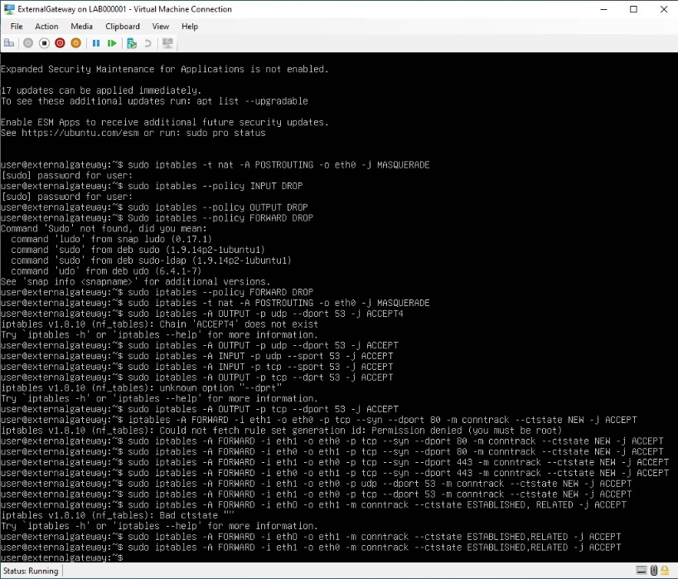**Ip tables**

**External Gateway**

* **IP tables with ports added**

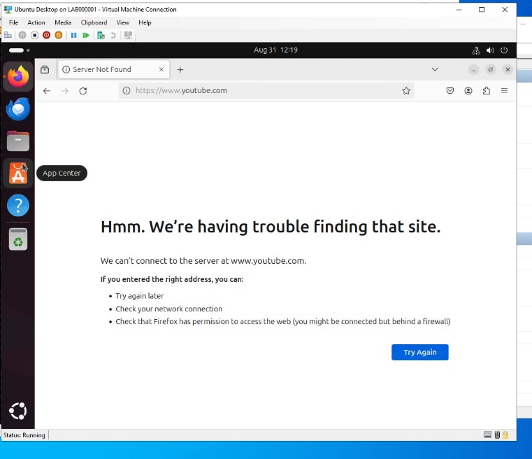

**Ubuntu Desktop**

* **Firewall in place**

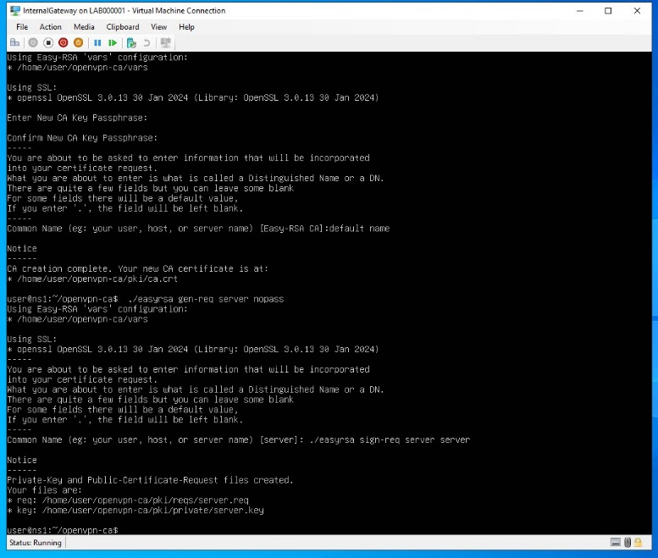

**Internal Gateway – Generate a sever crt and Key**

**Activity 4-2:**On the OpenVPN Client VM, connect to the OpenVPN server. On both the OpenVPN server and client, check their IP addresses, and show that new interfaces have been created for OpenVPN.

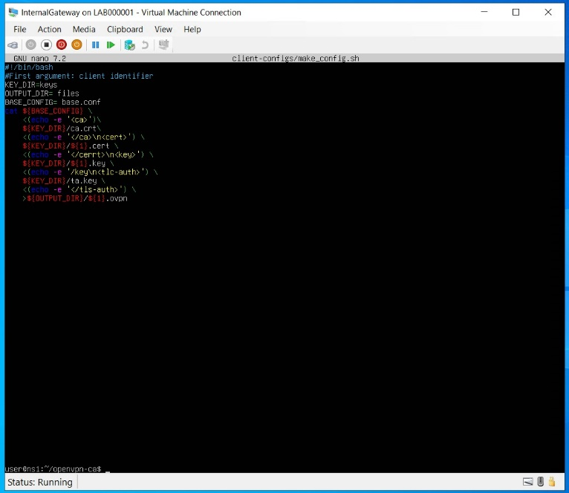

**Internal Gateway – make_config.sh**

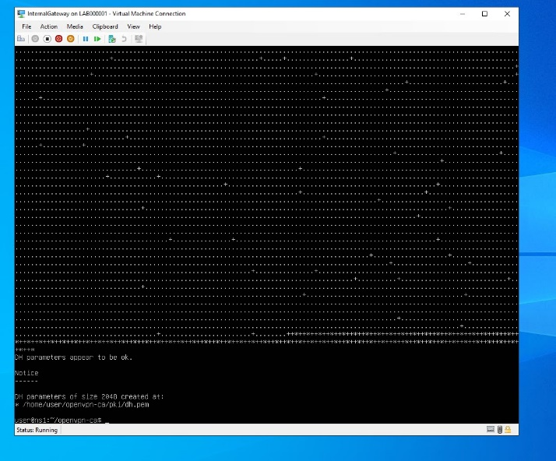

**Internal Gateway**

* A screenshot of a computer

  Description automatically generated**Diffie-Hellman Parameters**

**Internal Gateway – Build the CA**

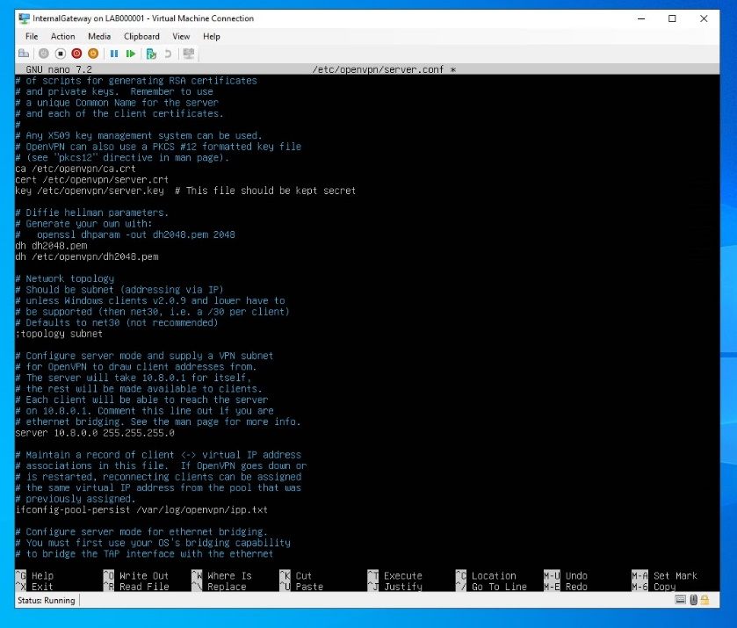

**Internal Gateway**

**– OpenVPN file**

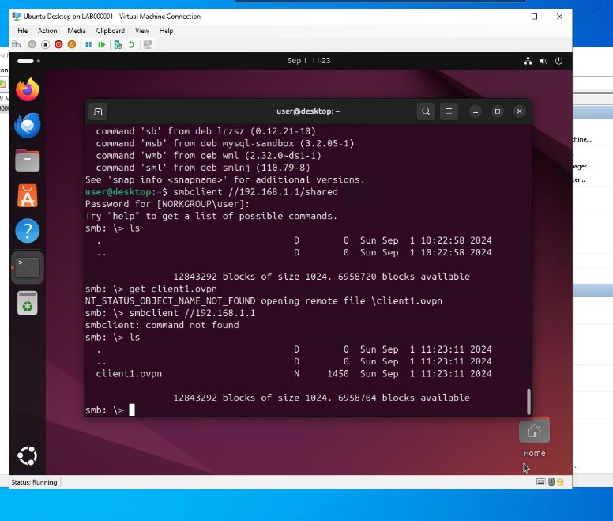

**Ubuntu Desktop – Smdclient**

**Internal Gateway**

**-make_config.sh**

**For Activity 4.2**

* I ended up with a lot of troubleshooting errors. I was able to install the VM with the OpenVPNclient but when uploading my client.ovpn file to the vpn I had a lot of file error and it wasn’t loading.
* I have figured out what the errors are in the file eg. Server.conf file format and client.conf format file. There was missing information in them that didn’t allow them to link properly.
* I do know the mistakes that are ahead to fix but due to timing I was unable to complete it before the assessment was due. I do have client.ovpn files on the OpenVPNclient but they are incorrect configuration.